 VIRTUAL REALITY TOURISM

**A PROJECT REPORT**

***Submitted by***

|  |  |
| --- | --- |
| **GOKUL S** | **(731220205009)** |
| **LENATAMILVANAN G** | **(731220205013)** |
| **RAVISANKARAN N** | **(731220205020)** |

*impartial fulfillment for the award of the degree*

***of***

# BACHELOR OF TECHNOLOGY

in

**INFORMATION TECHNOLOGY**

**J.K.K. MUNIRAJAH COLLEGE OF TECHNOLOGY**

**T.N. PALAYAM, GOBI-638506**

# ANNA UNIVERSITY: CHENNAI600 025



**MAY 2023**



# ANNA UNIVERSITY: CHENNAI 600 025

# BONAFIDE CERTIFICATE

Certified that this project report on **“VIRTUAL REALITY TOURISM”** is the Bonafide work of “**S. GOKUL (731220205009) and G. LENATAMILVANAN (731220205013)** and

**N. RAVISANKARAN (731220205020),”** who carried out the project work under My

supervision.

**SIGNATURE SIGNATURE**

**Dr.N. SATHYABALAJIM.E.Ph.D.,M.I.S.T.E Dr.N. SATHYABALAJIM.E.Ph.D.,M.I.S.T.E**

**ASSOCIATE PROFESSOR ASSOCIATE PROFESSOR**

**HEAD OF THE DEPARTMENT SUPERVISOR**

Dept. of Information Technology Dept of Information Technology

J.K.K. Munirajah College of Technology J.K.K. Munirajah College of Technology

T.N. Palayam T.N. Palayam

Submitted for the Viva-Voce examination held on

**INTERNAL EXAMINER EXTERNAL EXAMINER**

# ACKNOWLEDGEMENT

We express our sincere thanks and grateful acknowledgement to our Chairman **Dr. J.K.K. MUNIRAJAH M.Tech (Bolton). D.Litt.** for providing all facilities during the course of study in this college.

We would like to express our thanks to our secretary madam

**Mrs. KASTHURIPRIYA KRUPAKARMURALI, M.B.A.,** who has provided all the available facilities and support that had help us in the completion of our project.

We have immense pleasure in expressing my extreme gratitude thanks to our beloved Principal **Dr. K. SRIDHARAN M.E M.B.A., Ph.D., M.I.S.T.E.,** for his encouragement and support.

We wish to express our heartfelt thanks to our respect full Head of The Department **Dr. N. SATHYABALAJI M.E., M.I.S.T.E., Ph.D.** for his inspiring help, guidance, efforted energy in the right direction for completing this project.

Weal so thanks our guide **Dr. N. SATHYABALAJI M.E., M.I.S.T.E., Ph.D.** Associate Professor, Department of Computer Science and Engineering, who has been driving force to unveil the immense talent sinus.

We sincerely thank our lovable parents for their motivation and great support to complete this project successfully.

We also thank all the teaching and non-teaching staffs of the Department of Computer Science and Engineering and all my friends for their help and support to complete this project successfully.

# ABSTRACT

Virtual reality (VR) technology has revolutionized the way we experience and explore the world. This abstract provides an overview of the concept of virtual reality tourism and its implications for the travel industry. Virtual reality tourism refers to the use of VR technology to create immersive and interactive simulations of real or imagined travel destinations. By putting on a VR headset, users can transport themselves to any location, whether it's a bustling city, a historical site, or a natural wonder, and experience it as if they were physically present. The abstract highlights the benefits of virtual reality tourism, including its ability to overcome physical limitations, provide cost-effective travel alternatives, and enhance educational and cultural experiences. Additionally, it discusses the potential challenges and considerations associated with VR tourism, such as the need for high-quality content creation, technological accessibility, and maintaining a balance between virtual and physical travel experiences. The abstract concludes by emphasizing the growing importance of virtual reality tourism as a tool for destination marketing, customer engagement, and the democratization of travel experiences.

# TABLE OF CONTENTS

|  |  |  |
| --- | --- | --- |
| **CHAPTER NO.** | **TITLE** | **PAGE NO.** |
|  | **ACKNOWLEDGEMENTABSTRACT** | iiiiv |
|  | **LIST OF FIGURES** | viii |
|  | **LIST OF ABBREVIATIONS** | ix |
| **1** | **INTRODUCTION** | 1 |
|  | 1.1OVERVIEW OF THE PROJECT | 1 |
| **2** | **SYSTEM ANALYSIS** | 2 |
|  | 2.1EXISTINGSYSTEM  2.1.1 DRAWBACKS OF EXISTING  SYSTEM | 2  3 |
|  | 2.2PROPOSEDSYSTEM  2.2.1 ADVANTAGES OF PROPOSED  SYSTEM | 3  3 |
|  | 2.3FEASIBILITYSTUDY | 3 |
|  | 2.3.1ECONOMICAL FEASIBILITY | 4 |
|  | 2.3.2TECHNICAL FEASIBILITY | 4 |
|  | 2.3.3OPERATIONAL FEASIBILIT | 5 |
| **3** | **SYSTEM SPECIFICATION**  3.1 HARDWARE SPECIFICATION  3.2 SOFTWARE SPECIFICATION | 6  6  6 |
|  | 3.3 LANGUAGE USED | 7 |
|  | 3.3.1 HTML | 7 |
|  | 3.3.2 CSS | 9 |
|  | 3.3.3 JAVA SCRIPT | 10 |

**4. SYSTEM DESIGN AND DEVELOPMENT**

4.1SYSTEM DESIGN  11

4.1.1 FILE DESING 11

4.1.2 INPUT DESING 12

4.1.3 OUTPUT DESING 13

4.1.4 DATABASE DESING 17

4.2 DESCRIPTION OF MODULES 20

4.2.1 DASHBOARD MODULE 20

4.2.3 EXPIRY NOTIFICATION MODULE  21

4.2.4 PURCHASE MODULE 22

4.2.5 SALES MODULE 23

4.2.6 INVENTORY MODULE 24

4.2.7 REPORT MODULE 24

5. TESTING AND IMPLEMENTATION 25

5.1 SYSTEM TESTING 25

5.2 TYPES OF TESTING 25

5.2.1 UNIT TESTING 26

5.2.2 VALIDATION TESTING 26

5.2.3 ACCEPTANCE TESTING 26

5.2.4 OUTPUT TESTING 26

5.2.5 SYSTEM IMPLEMENTATION 27

6 CONCLUSION AND FUTURE ENHANCEMENT 29

6.1 CONCLUSION 29

6.2 FUTURE ENHANCEMENT 29

7 APPENDICES 30

7.1 SOURCE CODE 31

7.2 SCREENSHOTS 45

8 REFERENCES 50

# LIST OF FIGURES

|  |  |  |
| --- | --- | --- |
| **FIGURE NO** | **TITLE** | **PAGE NO.** |
| 1.1.1 | VIRTUAL REALITY GLASS | 1 |
| 4.2.1 | USE CASE DIAGRAM | 21 |
| 4.2.3 | VIRTUALTOURISM DIAGRAM | 22 |
| 4.2.1 | DATA FLOW DIAGRAM | 23 |

|  |  |
| --- | --- |
| **ABBREVIATIONS** | **EXPANSION** |
|  |  |
| HTML | HYPER TEXT MARKUP LANGUAGE |
| CSS | CASCADING STYLE SHEETS |
| BS2 | BOOT STARP 2 |
| JS | JAVA SCRIPT |
| VR | VIRTUAL REALITY |

# CHAPTER 1

**INTRODUCTION**

# 1.1 OVERVIEW OF THE PROJECT

Virtual tourism projects aim to provide immersive and interactive experiences that allow individuals to explore destinations and cultural attractions remotely. These projects typically utilize virtual reality (VR), augmented reality (AR), or 360-degree video technologies to create realistic and engaging environments. By leveraging these technologies, virtual tourism projects offer users the opportunity to virtually visit landmarks, museums, historical sites, natural wonders, and more, all from the comfort of their own homes. These projects often incorporate informative content, interactive elements, and sometimes even live guides or expert commentary to enhance the user experience. Virtual tourism can provide access to destinations that may be difficult to visit physically, promote cultural exchange, and serve as a valuable tool for education, entertainment, and exploration. Virtual tourism projects often involve partnerships with tourism boards.

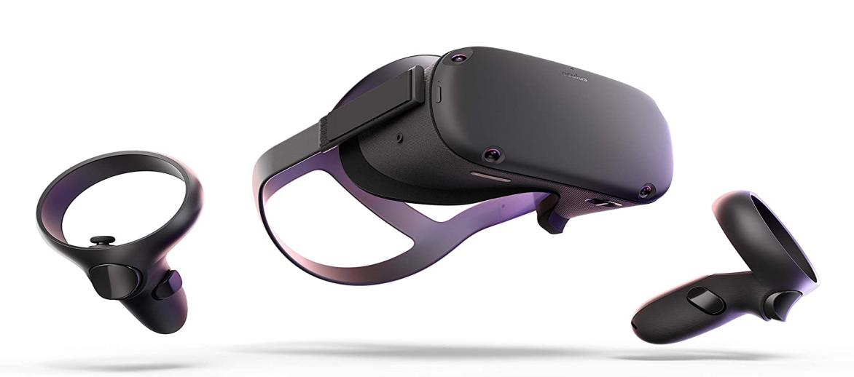

**Figure1.1.1** Virtual Reality Glass

**CHAPTER 2**

# SYSTEM ANALYSIS

Virtual tourism system analysis involves examining the components and functionalities of a virtual tourism system to evaluate its effectiveness, efficiency, and user experience. Here are the key aspects typically considered in a virtual tourism system analysis:

**2.1 EXISTING SYSTEM**

As of my knowledge cutoff in September 2021, there are several existing virtual tourism systems and platforms that have gained popularity. Here are a few examples: Google Arts & Culture: This platform offers virtual tours of famous museums, landmarks, and cultural sites around the world. It provides high-resolution images, 360-degree videos, and detailed information about the locations. Oculus Venues: Developed by Oculus, this virtual reality platform allows users to attend live events, concerts, and sports games virtually. It provides an immersive experience with 360-degree views and interactive features. YouVisit: YouVisit offers a range of virtual tours for destinations, universities, and attractions. Users can explore various locations through interactive 360-degree videos, images, and informative content. VRC hat: Varchar is a social virtual reality platform where users can create and explore virtual worlds. It allows for user-generated content, social interaction, and the exploration of diverse virtual environments. Expedia Virtual Tours: Expedia offers virtual tours for popular travel destinations and attractions. Users can virtually explore and learn about different places through interactive 360-degree images and videos.

# 2.1.1 DRAWBACKS OF EXISTING SYSTEM

* Lack of Physical Presence
* Limited Authenticity and Realism.
* Emotional Connection
* Physical Limitation.

# 2.2 PROPOSED SYSTEM

A proposed system in virtual tourism would aim to address the limitations and drawbacks of existing systems. Here are some potential features and improvements that could be included. Utilize advanced virtual reality (VR) or augmented reality (AR) technologies to create more realistic and immersive experiences. Incorporate high-resolution visuals, spatial audio, haptic feedback, and even scent simulations to replicate the sensory aspects of a destination. Interactive and Dynamic Environments.

**2.2.1 ADVANTAGES OF PROPOSED SYSTEM**

* Interactivity and Engagement
* Personalization and Customization
* Social Interaction and Collaboration
* accessible and Inclusive
* Educational Opportunities

# 2.3 FEASIBILITY STUDY

A feasibility study in virtual tourism would assess the practicality and viability of implementing a virtual tourism system. Here are some key factors that would be considered in such a study. It would help stakeholders make informed decisions regarding the viability and potential success of the proposed system, enabling them to plan effectively and allocate resources accordingly.

The following feasibility technique has been used in this project

* Economic Feasibility
* Technical Feasibility
* Operational Feasibility

# 2.3.1 ECONOMIC FEASIBILITY

Economic feasibility in virtual tourism refers to assessing the financial viability and potential profitability of implementing a virtual tourism system. Here are some key considerations for conducting an economic feasibility study in virtual tourism. An economic feasibility study in virtual tourism provides insights into the financial viability and potential profitability of implementing a virtual tourism system. It helps stakeholders make informed decisions regarding investments, pricing strategies, and revenue generation approaches to ensure the long-term sustainability and success of the virtual tourism venture.

**2.3.2 TECHNICAL FEASIBILITY**

Technical feasibility in virtual tourism refers to evaluating the technological aspects and determining if it is practical and achievable to develop and implement a virtual tourism system. Here are some key considerations for conducting a technical feasibility study in virtual tourism. A technical feasibility study in virtual tourism helps determine if the required technologies, infrastructure, and development capabilities are available to implement a virtual tourism system. It provides insights into the technical challenges, potential solutions, and the feasibility of achieving the desired functionality and performance.

**2.3.3. OPERATIONAL FEASIBILITY**

Operational feasibility in virtual tourism refers to assessing whether a proposed virtual tourism system can be effectively implemented and operated within the existing operational framework. It involves evaluating the practicality, resources, and processes needed to deploy and maintain the system. Here are some key considerations for conducting an operational feasibility study in virtual tourism.

# CHAPTER 3

**SYSTEM SPECIFICATION**

# 3.1 SOFTWARE SPECIFICATIONS

* + - Browser **:** Chrome Browser
    - Application : V360*

# 3.2 HARDWARE SPECIFICATIONS

* + - Mobile : Android (or) IOS
    - VR Glass : Mobile VR glass
    - Audio : Head set

# 3.3 LANGUAGES USED

# 3.3.1 HTML

HTML is an acronym which stands for **Hyper Text Markup Language** which is used for creating web pages and web applications. Let's see what is meant by Hypertext Markup Language, and Web page.

**Hyper Text:**

Hypertext simply means "Text within Text." A text has a link within it, is a hypertext. Whenever you click on a link which brings you to a new webpage, you have clicked on a hypertext. Hypertext is a way to link two or more web pages (HTML documents) with each other.

**Markup language:**

 A markup language is a computer language that is used to apply layout and formatting conventions to a text document. Markup language makes text more interactive and dynamic. It can turn text into images, tables, links, etc.

**Web Page**:

A web page is a document which is commonly written in HTML and translated by a web browser. A web page can be identified by entering an URL. A Web page can be of the static or dynamic type. With the help of HTML only, we can create static web pages.

Hence, HTML is a markup language which is used for creating attractive web pages with the help of styling, and which looks in a nice format on a web browser. An HTML document is made of many HTML tags and each HTML tag contains different content.

**Description of HTML Example**

**<!DOCTYPE>:** It defines the document type or it instruct the browser about the version of HTML.

**<html >: This** tag informs the browser that it is an HTML document. Text between html tag describes the web document. It is a container for all other elements of HTML except <!DOCTYPE>

**<head>:** It should be the first element inside the <html> element, which contains the metadata (information about the document). It must be closed before the body tag opens.

**<title>:** As its name suggested, it is used to add title of that HTML page which appears at the top of the browser window. It must be placed inside the head tag and should close immediately. (Optional)

**<body>**: Text between body tag describes the body content of the page that is visible to the end user. This tag contains the main content of the HTML document.

**<h1>**: Text between <h1> tag describes the first level heading of the webpage.

**HTML Versions:**

Since the time HTML was invented, there are lots of HTML versions in market, the brief introduction about the HTML version is given below:

HTML 1.0: The first version of HTML was 1.0, which was the barebones version of HTML language, and it was released in1991.

HTML 2.0: This was the next version which was released in 1995, and it was standard language version for website design

HTML 3.2: HTML 3.2 version was published by W3C in early 1997. This version was capable of creating tables and providing support for extra options for form elements. It can also support a web page with complex mathematical equations. It became an official standard for any browser till January 1997. Today it is practically supported by most of the browsers.HTML 4.01: HTML 4.01 version was released on December 1999, and it is a very stable version of HTML language. This version is the current official standard, and it provides added support for stylesheets (CSS) and scripting ability for various multimedia elements.

HTML5: HTML5 is the newest version of HyperText Markup language. The first draft of this version was announced in January 2008. There are two major organizations one is W3C (World Wide Web Consortium), and another one is WHATWG (Web Hypertext Application Technology Working Group)

**3.3.2 CSS**

CSS stands for Cascading Style Sheets. It is a style sheet language which is used to describe the look and formatting of a document written in markup language. It provides an additional feature to HTML. It is generally used with HTML to change the style of web pages and user interfaces. It can also be used with any kind of XML documents including plain XML, SVG and XUL.CSS is used along with HTML and JavaScript in most websites to create user interfaces for web applications and user interfaces for many mobile applications.

**Why use CSS**

These are the three major benefits of CSS:

* Solves a big problem
* Backward Skip 10s
* Play Video
* Forward Skip 10s

Before CSS, tags like font, color, background style, element alignments, border and size had to be repeated on every web page. This was a very long process. For example: If you are developing a large website where fonts and color information are added on every single page, it will be become a long and expensive process. CSS was created to solve this problem. It was a W3C recommendation.

**2) Saves a lot of time**

CSS style definitions are saved in external CSS files so it is possible to change the entire website by changing just one file.

**3) Provide more attributes**

CSS provides more detailed attributes than plain HTML to define the look and feel of the website.

**3.3.3 JavaScript**

* What is JavaScript
* Backward Skip 10s
* Play Video
* Forward Skip 10s

JavaScript (JS) is a light-weight object-oriented programming language which is used by several websites for scripting the web pages. It is an interpreted, full-fledged programming language that enables dynamic interactivity on websites when applied to an HTML document. It was introduced in the year 1995 for adding programs to the webpages in the Netscape Navigator browser. Since then, it has been adopted by all other graphical web browsers. With JavaScript, users can build modern web applications to interact directly without reloading the page every time. The traditional website uses is to provide several forms of interactivity and simplicity. Although, JavaScript has no connectivity with Java programming language. CouchDB and MongoDB uses JavaScript as their scripting query language.

# CHAPTER 4

**SYSTEM DESIGN AND DEVELOPMENT**

# 

# 4.1 SYSTEM DESIGN

**4.1.1 FILE DESIGN**

This system contains the menus for various kinds of operations. Menus and Files are created for displaying the information about user and company. This system also contains the command buttons as part of the user interface. Information systems in business are file and database oriented. Data are accumulated into files that are proposed or maintained by the system. The system analyst is responsible for designing files, determining their contents and selecting method for organizing the data. System analysis decide the following input design details like, what data to input, what medium to use, how the data should be arranged or coded, data items and transaction needing validations to detect errors and at last the dialogue to guide user in providing input.

File designs are forms which as follows,

* + - USER
    - HOME
    - POPULAR PLACES
    - ABOUT
    - TEAM
    - ADMIN
    - ADD PLACES
    - SHOOT VEDIO
    - EDIT

**4.1.2 INPUT DESING**

Selection Mechanisms: Design mechanisms for users to select destinations, attractions, or specific points of interest within the virtual tourism system. This can include clickable icons, buttons, dropdown menus, or interactive maps. Consider the ease of selection and provide visual cues or animations to enhance the user experience.

**Input Validation:**

Implement input validation to ensure that user input is accurate and conforms to the system's requirements. Validate user inputs such as search queries, forms, or preferences to prevent errors and provide informative error messages when necessary.

**Personalization and Customization:**

Allow users to personalize their virtual tourism experience by providing options for customization. This can include preferences for language, display settings, content filters, or saved preferences. Design input mechanisms that allow users to set their preferences and reflect them throughout the system.

**Accessibility Considerations:**

Ensure that the input design considers accessibility requirements for users with disabilities. Provide alternative input options for users who may have difficulty with standard input mechanisms. Support accessibility features such as voice commands, screen readers, or alternative input devices.

**User Feedback:**

Incorporate user feedback mechanisms to gather input from users regarding their experiences, preferences, or issues encountered.

**Usability Testing:**

Conduct usability testing to evaluate the effectiveness of the input design. Observe users interacting with the system, gather feedback, and make necessary refinements based on user behavior and preferences. Iteratively test and improve the input design to ensure a seamless and engaging user experience.

Identifying the data needed, specifying the characteristics of each data item, capturing & preparing data for computer processing and ensuring correctness of data.

* Admin will basically be able to access all the modules in the application and will have the option to approve a booking request raised by a user or user.
* User is an internal college who can log in and request for auditorium booking for a specific date and time interval.
* Menu driven programming is very easy to access the programs Login–user name, password
* Add admin–a domain name, password, email id, mobile no and etc.,
* Add product-Product name, price, description, category etc.,
* Add message–text with submit button.

# 4.1.3 OUTPUT DESIGN

# Output design in virtual tourism refers to the process of presenting information, visuals, and feedback to users in a clear, engaging, and meaningful manner. It focuses on creating an immersive and visually appealing output that enhances the virtual tourism experience.

**Visual Presentation:**

Design visually appealing and realistic graphics that accurately represent the destinations, attractions, or experiences within the virtual tourism system. Use high-quality images, videos, 3D models, or interactive elements to create a compelling visual experience.

Virtual Environment Design: Create a captivating virtual environment that immerses users in the virtual tourism experience. Pay attention to details such as scenery, lighting, textures, and animations to enhance realism and create an engaging atmosphere.

**Information Display**:

Present relevant and contextual information to users within the virtual tourism system. This can include details about destinations, attractions, historical facts, or interactive guides. Ensure that the information is easily accessible, properly organized, and displayed in a visually pleasing manner.

Navigation and Wayfinding: Provide clear and intuitive navigation cues to guide users within the virtual environment. Design visual markers, paths, or directional signs to help users navigate through different destinations or attractions. Use visual cues, such as arrows or highlighted areas, to indicate points of interest or interactive elements.

**Feedback and Interactivity:**

Provide meaningful feedback to users based on their interactions within the virtual tourism system. This can include audio or visual cues, animations, or haptic feedback to reinforce user actions and enhance the sense of immersion. Incorporate interactive elements that respond to user input, such as clickable objects or interactive hotspots.

**Multi-Sensory Experience:**

Design the output to engage multiple senses, such as visual, auditory, and haptic feedback. Incorporate spatial audio to provide a realistic sound environment that corresponds to the user's location within the virtual environment. Consider haptic feedback or vibrations to simulate tactile experiences where applicable.

**User Engagement and Interaction:**

Encourage user engagement and active participation within the virtual tourism system. Design interactive elements, puzzles, quizzes, or gamified experiences that allow users to actively explore and interact with the virtual environment. Provide rewards, achievements, or progress indicators to motivate and engage users.

**Personalization and Customization:**

Allow users to personalize their output preferences within the virtual tourism system. Provide options for language selection, display settings, or content filters to cater to individual preferences. Design output elements that dynamically adapt to user preferences to create a personalized experience.

**Accessibility Considerations:**

Ensure that the output design considers accessibility requirements for users with disabilities. Provide alternative output options, such as subtitles or captions for audio content, alternative text for visual content, or adjustable font sizes. Support accessibility features to make the virtual tourism experience inclusive for all users.

**Usability Testing:**

Conduct usability testing to evaluate the effectiveness of the output design. Observe users interacting with the system, gather feedback, and make necessary refinements based on user preferences and behavior. Continuously test and improve the output design to ensure a seamless and captivating virtual tourism.

Effective output design in virtual tourism plays a crucial role in creating an immersive and engaging experience for users. By considering factors such as visual presentation, virtual environment design, information display, feedback and interactivity, multi-sensory experience, user engagement, personalization, accessibility, and usability, the output design aims to deliver a compelling and enjoyable virtual tourism experience.

Computer output is the most important and direct source of information to the user. Efficient, intelligible output design should improve the systems. It defines relationships with the user and help indecision making. A major form of output is a hard copy from the printer. Printout should be designed around the output requirement of the user. The output device with system, response time requirements, expected print quality and number of copies needed.

In this system uses the list box, combo box for output display. The bills a real so used to be format of database grid. Mostly the outputs will be displayed on the screens as reports.

# 4.1.4 DATABASE DESIGN

Database design in virtual tourism involves structuring and organizing the data necessary for the virtual tourism system to function effectively. It focuses on designing a database schema that efficiently stores and manages the relevant information required for destinations, attractions, user profiles, bookings, and other aspects of the virtual tourism experience. Here are some key considerations for database design in virtual tourism:

**Identify Entities and Relationships:**

Identify the main entities involved in the virtual tourism system, such as destinations, attractions, users, bookings, reviews, and multimedia assets. Determine the relationships between these entities, such as one-to-many or many-to-many relationships, to establish the appropriate structure for the database.

**Define Entity Attributes**:

Determine the attributes or properties associated with each entity. For example, destination attributes may include name, description, location, and image, while user attributes may include name, email, password, and preferences. Define appropriate data types and constraints for each attribute to ensure data integrity.

**Normalization:**

Apply normalization techniques to eliminate data redundancy and improve data integrity. Normalize the database schema by breaking it down into smaller tables, each serving a specific purpose. This helps reduce data duplication and ensures efficient data storage and retrieval.

Data Integrity and Constraints: Implement data integrity constraints to maintain the accuracy and consistency of data. Define primary keys, foreign keys, and unique constraints to enforce relationships between tables and prevent inconsistent or invalid data entries.

**Indexing:**

Identify the fields that are frequently used for searching or sorting data and create appropriate indexes. Indexing improves the performance of database queries by facilitating faster data retrieval.

**Multimedia Storage:**

Determine the most suitable approach for storing and managing multimedia assets such as images, videos, or 3D models associated with destinations and attractions. Evaluate options such as storing the files directly in the database or using file storage systems and referencing their locations in the database.

**Security and Privacy:**

Implement appropriate security measures to protect sensitive data. Apply access controls, encryption techniques, and authentication mechanisms to safeguard user information, booking details, and other confidential data. Ensure compliance with data privacy regulations.

**Scalability and Performance:**

Design the database to handle growing data volumes and increasing user demand. Consider techniques such as partitioning, clustering, or sharing to distribute the database across multiple servers for improved scalability and performance.

**Data Backup and Recovery:**

Implement regular backup procedures to protect against data loss. Establish mechanisms for scheduled backups, offsite storage, and data recovery in case of system failures or disasters.

**Integration and APIs**:

Design the database to support integration with external systems, such as payment gateways, booking platforms, or analytics tools. Define appropriate APIs or data exchange mechanisms to enable seamless data flow between the virtual tourism system and external systems.

Database design in virtual tourism plays a critical role in ensuring efficient data storage, retrieval, and management. By considering factors such as entity identification, relationship establishment, attribute definition, normalization, data integrity, indexing, multimedia storage, security, scalability, performance, backup, recovery, and integration, the database design aims to provide a solid foundation for the virtual tourism system to deliver a seamless and reliable user experience.

# 4.2 DESCRIPTION OF MODULES

The Modules in virtual tourism can vary depending on the specific features and functionalities of the virtual tourism system. However, here are some common modules that are often found in virtual tourism systems.

In that proposed system module like

Destination Management

Attraction Showcase

Virtual Environment

User Management

Booking and Reservation

Social Interaction

Analytics and Reporting

Administration and Content Management

**4.2.1 DASHBOARD MODULE**

The dashboard module in virtual tourism provides an overview and centralized access to key information and functionalities for both users and administrators. It serves as a user interface that presents relevant data and allows users to manage their virtual tourism activities. Here are some common features and functionalities of the dashboard module in virtual tourism:

**4.2.2 EXPIRY NOTIFICATION MODULE**

The expiry notification module in virtual tourism is responsible for sending automated notifications to users or administrators when certain time-limited aspects of the virtual tourism system are about to expire. Here are some key features and functionalities of the expiry notification module:

# Virtual Tourism Management

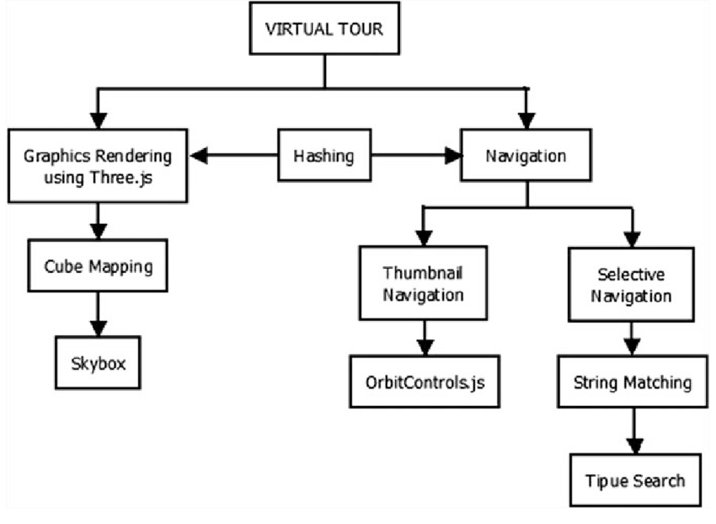

Figure4.2.1 Use case Diagram

# 4.2.3 PURCHASE MODULE

# The purchase module in virtual tourism facilitates the process of purchasing virtual tourism experiences, services, or products within the virtual tourism system. It enables users to make payments and complete transactions seamlessly. Here are some key features and functionalities of the purchase module:

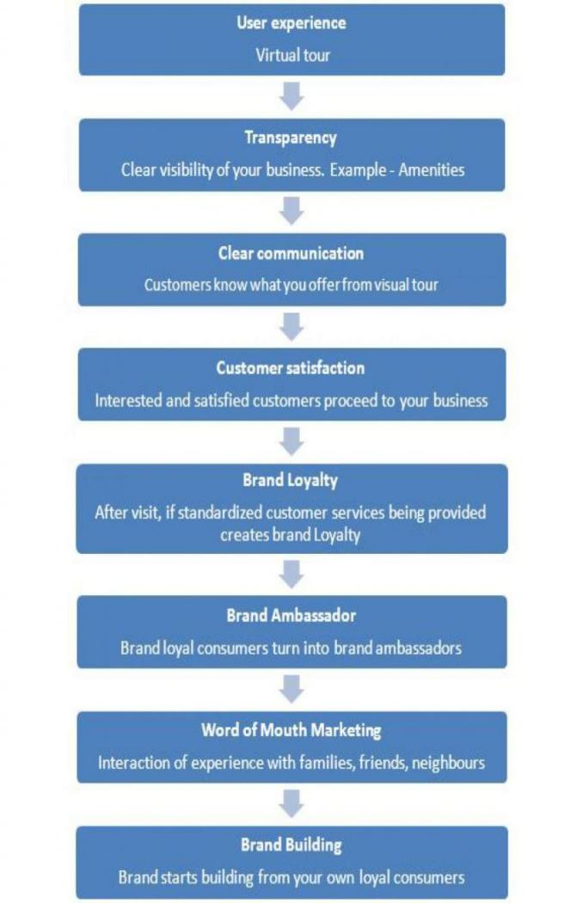

Figure4.2.2Virtual Tourism Diagram

# 

# 4.2.3 SALES MODULE

# The sales module in virtual tourism focuses on managing and tracking the sales activities within the virtual tourism system. It includes features and functionalities that support the sales process, customer relationship management, and revenue generation. Here are some key components of the sales module in virtual tourism

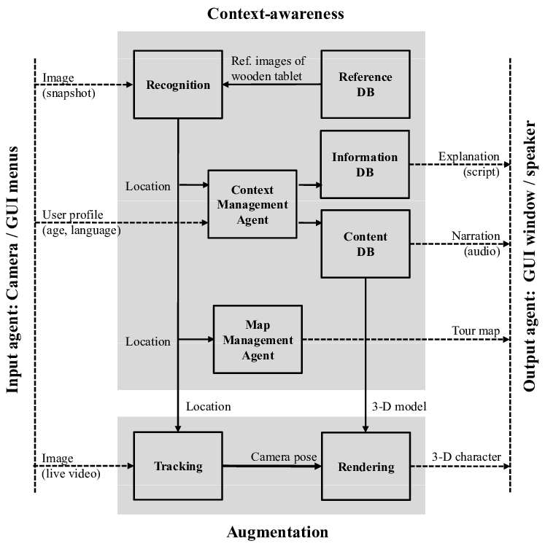

Figure4.2.3Dataflow Diagram

# 

# 4.2.4 INVENTORY MODULE

The inventory module in virtual tourism manages and tracks the availability of virtual tourism experiences, services, or products. It helps ensure accurate inventory management, availability tracking, and efficient utilization of resources. Here are some key components and functionalities of the inventory module in virtual tourism:

# 

# 4.2.5 REPORT MODULE

# The report is a collective data displayed in a pdf format, based on the search criteria, online virtual management software will generate all reports related to virtual management

# CHAPTER 5

**TESTING AND IMPLEMENTATION**

# 5.1 SYSTEM TESTING

The purpose of testing is to discover errors. Testing is the process of trying to discover every conceivable falter weakness in a work product. It provides away to check the functionality of components, sub-assemblies, assemblies and or a finished product. It is the process of exercising software with the intent of ensuring that the Software system meets its requirements and user expectations and does not fail in an unacceptable manner. There are various types of tests. Each test type addresses a specific test in requirement.

# 5.2 TYPES OF TESTING

* + - * + There are six testing phases
        + Unit testing
        + Validation testing
        + Acceptance testing
        + Output testing

# 5.3 UNIT TESTING

Unit testing involves the design of test cases that validate that the internal program logic is function improperly, and that program input produces valid outputs. All decision branches and internal code flow should be validated. It is the testing of individual software units of the application. It is done after the completion of an individual unit be for e integration.

# 5.4 VALIDATION TESTING

The procedure of validation testing is to keep the system safe from errors. The basic purpose is to conform that the system satisfies the necessary conditions. This testing is planned when the incorrect data is given; the user receives the error message. A test plan output lines the classes of test to be conducted and test aproceduredevicespecifictestcasethatwillbeusedtodemonstrateconformitywiththerequirements.

# 5.5 ACCEPTANCE TESTING

User Acceptance Testing is a critical phase of any project and requires sign if can’t participation by the end user.

# 5.6 OUTPUT TESTING

After performing the validation testing the next step is the output testing of the proposed system. Since no system could be useful if it does not produce the required output format. Asking the users about format required by them test the output generated or displayed by the system under consideration. Here the output form is considered on screen and in printed format.

# 5.7 SYSTEM IMPLEMENTATION

After having the user acceptance of then we system developed, the implementation phase begins. Implementation is the stage of a project during which theory is turned into practice. During this phase, all the programs of the system are loaded onto the user's computer. After loading the system, training of the users starts. Main topics of such type of training are

* How to execute the package
* How to enter the data
* How to process the data (processing details)
* How to take out their ports

After the users are trained about the computerized system, manual working has to shift from manual to computerized working. The following two strategies are followed for running the system:

* **Parallel run**

In such run for a certain defined period, both the systems i.e., computerized and manual are executed in parallel. This strategy is helpful because of the following:

Manual results can be compared with the results of the computerized system.

Failure of the computerized system at the early stage, does not affect the working of the organization, because the manual system continues to work, sit used to do.

# CHAPTER 6

**CONCLUSION AND FUTURE ENHANCEMENT**

# 

# 6.1 CONCLUSION

In conclusion, virtual tourism offers numerous benefits and opportunities for both tourists and the tourism industry. It leverages technology to provide immersive and interactive experiences that simulate real-world travel and exploration. Here are some key points to summarize the concept of virtual tourism Accessibility Virtual tourism breaks down barriers by making travel experiences accessible to a wider audience. People who are physically unable to travel or face limitations can still explore and enjoy virtual destinations from the comfort of their homes. Convenience and Flexibility: Virtual tourism offers convenience and flexibility by allowing users to access virtual experiences anytime, anywhere. It eliminates the need for extensive planning, travel arrangements, and time constraints associated with physical travel.

# 6.2 FUTURE ENHANCEMENT

The future of virtual tourism holds promising opportunities for enhancement and innovation. Here are some potential areas for future development and improvement in virtual tourism Advancements in Virtual Reality (VR) and Augmented Reality (AR): The use of VR and AR technologies in virtual tourism can become more sophisticated, offering more realistic and immersive experiences. Enhanced graphics, improved spatial tracking, and interactive elements can make virtual environments even more engaging. Seamless Integration of Artificial Intelligence (AI): AI can be integrated into virtual tourism systems to personalize and enhance user experiences. AI-powered chatbots and virtual assistants can provide real-time guidance, recommendations, and personalized itineraries, making virtual tours more interactive and tailored to individual preferences. Social Interaction and Collaboration: Future enhancements can focus on incorporating social elements into virtual tourism experiences. Users may be able to interact with fellow virtual tourists, participate in virtual group activities, or share their experiences through social media integration.

# APPENDICES

# SOURCECODE

# HTML

# <!DOCTYPE html>

# <html lang="en">

# <! --divinectorweb.com-->

# <head>

# <meta charset="UTF-8">

# <meta http-equiv="X-UA-Compatible" content="IE=edge">

# <meta name="viewport" content="width=device-width, initial-scale=1.0">

# <title>VR Visual</title>

# <! -- All CSS -->

# <link href="css/bootstrap.min.css" rel="stylesheet">

# <link rel="stylesheet" href="https://cdn.jsdelivr.net/npm/bootstrap-icons@1.7.2/font/bootstrap-icons.css">

# <link rel="stylesheet" href="css/style.css">

# </head>

# <body>

# <nav class="navbar navbar-expand-lg navbar-light bg-light fixed-top">

# <div class="container">

# <a class="navbar-brand" href="#"><span class="text-warning">VR</span>Visual</a>

# <button class="navbar-toggler" type="button" data-bs-toggle="collapse" data-bs-target="#navbarSupportedContent" aria-controls="navbarSupportedContent" aria-expanded="false" aria-label="Toggle navigation">

# <span class="navbar-toggler-icon"></span>

# </button>

# <div class="collapse navbar-collapse" id="navbarSupportedContent">

# <ul class="navbar-nav ms-auto mb-2 mb-lg-0">

# <li class="nav-item">

# <a class="nav-link" href="#">Home</a>

# </li>

# <li class="nav-item">

# <a class="nav-link" href="#about">About</a>

# </li>

# <li class="nav-item">

# <a class="nav-link" href="#services">Services</a>

# </li>

# <li class="nav-item">

# <a class="nav-link" href="#portfolio">Tourist Places</a>

# </li>

# <li class="nav-item">

# <a class="nav-link" href="#team">Team</a>

# </li>

# <li class="nav-item">

# <a class="nav-link" href="#contact">Contact</a>

# </li>

# </ul>

# </div>

# </div>

# </nav>

# <div id="carouselExampleIndicators" class="carousel slide" data-bs-ride="carousel">

# <div class="carousel-indicators">

# <button type="button" data-bs-target="#carouselExampleIndicators" data-bs-slide-to="0" class="active" aria-current="true" aria-label="Slide 1"></button>

# <button type="button" data-bs-target="#carouselExampleIndicators" data-bs-slide-to="1" aria-label="Slide 2"></button>

# <button type="button" data-bs-target="#carouselExampleIndicators" data-bs-slide-to="2" aria-label="Slide 3"></button>

# </div>

# <div class="carousel-inner">

# <div class="carousel-item active">

# <img src="images/bg1.jpg" class="d-block w-100" alt="...">

# <div class="carousel-caption">

# <h5>VR Experience</h5>

# <p>Virtual Reality Is a Simulated Experience That Empolyes Pose Tracking And 3D Near Eye Display TO Give The User An Immersive Feel Of The a Vitual World </p>

# <p><a href="#portfolio" class="btn btn-warning mt-3">Get Start</a></p>

# </div>

# </div>

# <div class="carousel-item">

# <img src="images/bg2.jpg" class="d-block w-100" alt="...">

# <div class="carousel-caption">

# <h5>VR Toursim</h5>

# <p>In the travel industry, Virtual Reality Can be used to capture tourism destination in a unique and immersive way!! </p>

# <p><a href="#portfolio" class="btn btn-warning mt-3">Get Start</a></p>

# </div>

# </div>

# <div class="carousel-item">

# <img src="images/bg3.jpg"class="d-block w-100" alt="...">

# <div class="carousel-caption">

# <h5>Travel In VR</h5>

# <p>The VR tourism video works much like a normal video. They can be viewed on social media or websites, but unlike a regular video, The user is able to explore the entire scene whiles the video is playing </p>

# <p><a href="#portfolio" class="btn btn-warning mt-3">Get strat</a></p>

# </div>

# </div>

# <button class="carousel-control-prev" type="button" data-bs-target="#carouselExampleIndicators" data-bs-slide="prev">

# <span class="carousel-control-prev-icon" aria-hidden="true"></span>

# <span class="visually-hidden">Previous</span>

# </button>

# <button class="carousel-control-next" type="button" data-bs-target="#carouselExampleIndicators" data-bs-slide="next">

# <span class="carousel-control-next-icon" aria-hidden="true"></span>

# <span class="visually-hidden">Next</span>

# </button>

# </div>

# <!-- about section starts -->

# <section id="about" class="about section-padding">

# <div class="container">

# <div class="row">

# <div class="col-lg-4 col-md-12 col-12">

# <div class="about-img">

# <img src="images/france-eiffel-tower-paris.jpg" alt="" class="img-fluid" style="width:50em; height:22em ;">

# </div>

# </div>

# <div class="col-lg-8 col-md-12 col-12 ps-lg-5 mt-md-5">

# <div class="about-text">

# <h2>We Provide the Best Video Quality <br/> Experience Ever</h2>

# <p>360-degree video is typically recorded using either a special rig of multiple cameras, or using a dedicated camera that contains multiple camera lenses embedded into the device, and recording overlapping angles simultaneously, Specialized omnidirectional cameras and rigs have been developed for the purpose of recording 360-degree video, including rigs such as GoPro's Omni and Odyssey (which consist of multiple action cameras installed within a frame), and contained cameras like the Nokia OZO.</p>

# <a href="https://en.wikipedia.org/wiki/Virtual_reality" target="_blank" class="btn btn-warning">Learn More</a>

# </div>

# </div>

# </div>

# </div>

# </section>

# <!-- about section Ends -->

# <!-- services section Starts -->

# <section class="services section-padding" id="services">

# <div class="container">

# <div class="row">

# <div class="col-md-12">

# <div class="section-header text-center pb-5">

# <h2>Our Services</h2>

# </div>

# </div>

# </div>

# <div class="row">

# <div class="col-12 col-md-12 col-lg-4">

# <div class="card text-white text-center bg-dark pb-2">

# <div class="card-body">

# <i class="bi bi-laptop"></i>

# <h3 class="card-title">Best Quality</h3>

# <p class="lead">It's measured by the number of pixels contained in the standard aspect ratio of 16:9, the most common aspect ratio for television and computer monitors.</p>

# <p style="width: 100%; border:solid 2px #ffc107;"></p>

# </div>

# </div>

# </div>

# <div class="col-12 col-md-12 col-lg-4">

# <div class="card text-white text-center bg-dark pb-2">

# <div class="card-body">

# <i class="bi bi-journal"></i>

# <h3 class="card-title">Sustainability</h3>

# <p class="lead">*DECREASING EMISSIONS,

# EDUCATION ON CLIMATE CHANGE,

# SAVE ON MATERIAL AND ENERGY WASTE,

# RECYCLED HARDWARE.<br><br>

# </p>

# <p style="width: 100%; border:solid 2px #ffc107;"></p></div>

# </div>

# </div>

# <div class="col-12 col-md-12 col-lg-4">

# <div style="border-top: #ffc107 10px;" class="card text-white text-center bg-dark pb-2">

# <div class="card-body">

# <i class="bi bi-intersect"></i>

# <h3 class="card-title">Impact of VR</h3><br>

# <p class="lead">The aim of the present study was to investigate the possible impact of virtual reality on curiosity.<br><br></p>

# <p style="width: 100%; border:solid 2px #ffc107;"></p>

# </div>

# </div>

# </div>

# </div>

# </div>

# </section>

# <!-- services section Ends -->

# <!-- portfolio strats -->

# <section id="portfolio" class="portfolio section-padding">

# <div class="container">

# <div class="row">

# <div class="col-md-12">

# <div class="section-header text-center pb-5">

# <h2>Tourist Places</h2>

# <p>Select Your Favorote Place And View 360* Real Experience</p>

# </div>

# </div>

# </div>

# <div class="row">

# <div class="col-12 col-md-12 col-lg-4">

# <div class="card text-light text-center bg-white pb-2">

# <div class="card-body text-dark">

# <div class="img-area mb-4">

# <img src="images/mettur.jpg" class="img-fluid" alt="" style="height: 15.2em; width: 20em;">

# </div>

# <h3 class="card-title">Mettur Dam</h3>

# <p class="lead" style="font-size:18px;">It was constructed in 1934 and took 9 years to complete. Maximum storage height is 120 feet. Mettur Dam receives the water from both Kabini Dam and Krishna Raja Sagara Dam located in Karnataka. It's On of the tourist place</p>

# <button class="btn bg-warning text-dark"><a href="mettur.html" target="_blank" style="text-decoration: none; color: black; ">VIEW</a></button>

# </div>

# </div>

# </div>

# <div class="col-12 col-md-12 col-lg-4">

# <div class="card text-light text-center bg-white pb-2">

# <div class="card-body text-dark">

# <div class="img-area mb-4">

# <img src="images/bhavanisagar.jpg" class="img-fluid" alt="">

# </div>

# <h3 class="card-title">Bhavani sagar DAM</h3>

# <p class="lead" style="font-size:18px;">The Lower Bhavani Project was the first major irrigation project initiated in India, after independence, in 1948. It was completed by 1955 and opened for use in 1956. The dam was constructed at a cost of ₹210 M</p>

# <button class="btn bg-warning text-dark"><a href="bhavanisagar.html" target="_blank" style="text-decoration: none; color: black;">VIEW</a></button>

# </div>

# </div>

# </div>

# <div class="col-12 col-md-12 col-lg-4">

# <div class="card text-light text-center bg-white pb-2">

# <div class="card-body text-dark">

# <div class="img-area mb-4">

# <img src="images/kodiveri.jpg" class="img-fluid" alt="" style="height: 15.2em;">

# </div>

# <h3 class="card-title">Kodiveri DAM</h3>

# <p class="lead" style="font-size:18px;"> It was constructed by Kongalvan Vettuva Gounder King in the year 1125 AD. Creating the dam consisted of carving a 20-foot wall of rock. The stones were then interlocked with iron bars and lead was used as mortar</p>

# <button class="btn bg-warning text-dark"><a href="kodiveri.html" target="_blank" style="text-decoration: none; color: black;">VIEW</a></button>

# </div>

# </div>

# </div>

# <div class="col-12 col-md-12 col-lg-4">

# <div class="card text-light text-center bg-white pb-2">

# <div class="card-body text-dark">

# <div class="img-area mb-4">

# <img src="images/koodudurai.jpg" class="img-fluid" alt="">

# </div>

# <h3 class="card-title">Sangameshwarar Temple</h3>

# <p class="lead" style="font-size:18px;">In Sangameshwar the two rivers Sonavi and Shastri flow together. The meaning of Sangama in Marathi (and most Indian languages) is confluence, and so the name "Sangameshwar". It's on the Popular place in erode and tourist place.</p>

# <button class="btn bg-warning text-dark"><a href="koodudurai.html" target="_blank" style="text-decoration: none; color: black;">VIEW</a></button>

# </div>

# </div>

# </div>

# <div class="col-12 col-md-12 col-lg-4">

# <div class="card text-light text-center bg-white pb-2">

# <div class="card-body text-dark">

# <div class="img-area mb-4">

# <img src="images/bannari.jpg" class="img-fluid" alt="" style="height: 12em;">

# </div>

# <h3 class="card-title">Bannari amman Temple</h3>

# <p class="lead" style="font-size:18px;">Bannari Amman temple is one of the Amman temples in Tamil Nadu, India. It is located in Bannari on NH 209, near Sathyamangalam, Erode district. The main deity at the temple is goddess Mariamman (the goddess of rain), an avatar of goddess Parvathi.</p>

# <button class="btn bg-warning text-dark"><a href="bannari.html" target="_blank" style="text-decoration: none; color: black;">VIEW</a></button>

# </div>

# </div>

# </div>

# <div class="col-12 col-md-12 col-lg-4">

# <div class="card text-light text-center bg-white pb-2">

# <div class="card-body text-dark">

# <div class="img-area mb-4">

# <img src="images/jkkm.jpg" class="img-fluid" alt="">

# </div>

# <h3 class="card-title">JKKM College Of Technology</h3>

# <p class="lead" style="font-size:18px;">The college is approved by AICTE and is affiliated with the Anna University Coimbatore. The college was established in the academic year 2008-2009 and governed by the Annai J.K.K. Sampoorani Ammal Charitable Trust. The college covers an area of 250 acres.</p>

# <button class="btn bg-warning text-dark"><a href="jkkm.html" target="_blank" style="text-decoration: none; color: black;">VIEW</a></button>

# </div>

# </div>

# </div>

# </div>

# </div>

# </section>

# <!-- portfolio ends -->

# <!-- team starts -->

# <section class="team section-padding" id="team">

# <div class="container">

# <div class="row">

# <div class="col-md-12">

# <div class="section-header text-center pb-5">

# <h2>Our Team</h2>

# <p>Everyone does better when we all do better.</p>

# </div>

# </div>

# </div>

# <div class="row">

# <div class="col-12 col-md-6 col-lg-4">

# <div class="card text-center">

# <div class="card-body">

# <img src="images/ravi.jpg" alt="" class="img-fluid rounded-circle" style="height: 10em; width: 10em;">

# <h3 class="card-title py-2">N.Ravisankaran</h3>

# <p class="socials">

# <a href="https://twitter.com/NRavisankaran?t=DIJA6MdN5lMqTatIRBnGIQ&s=09"><i class="bi bi-twitter text-dark mx-1"></i></a>

# <a href="https://www.facebook.com/lee.ravi.96?mibextid=ZbWKwL"><i class="bi bi-facebook text-dark mx-1"></i></a>

# <a href="https://www.linkedin.com/in/ravisankaran-n-54739a246"><i class="bi bi-linkedin text-dark mx-1"></i></a>

# <a href="https://instagram.com/ravi_jackie007?igshid=YmMyMTA2M2Y="><i class="bi bi-instagram text-dark mx-1"></i></a>

# </p>

# </div>

# </div>

# </div>

# <div class="col-12 col-md-6 col-lg-4">

# <div class="card text-center">

# <div class="card-body">

# <img src="images/gokul.jpg" alt="" class="img-fluid rounded-circle" style="height: 10em; width: 10em;">

# <h3 class="card-title py-2">S.Gokul</h3>

# <p class="socials">

# <a href=""><i class="bi bi-twitter text-dark mx-1"></i></a>

# <a href="https://www.facebook.com/profile.php?id=100055017965450"><i class="bi bi-facebook text-dark mx-1"></i></a>

# <a href="https://www.linkedin.com/in/gokul-btech-723b1224a"><i class="bi bi-linkedin text-dark mx-1"></i></a>

# <a href="https://instagram.com/mr_dare_devil__007?igshid=YmMyMTA2M2Y="><i class="bi bi-instagram text-dark mx-1"></i></a>

# </p>

# </div>

# </div>

# </div>

# <div class="col-12 col-md-6 col-lg-4">

# <div class="card text-center">

# <div class="card-body">

# <img src="images/1lena.jpg" alt="" class="img-fluid rounded-circle" style="height: 10.2em; width: 10.2em;">

# <h3 class="card-title py-2"style="font-size: 25px;">G.Tamilvanan</h3>

# <p class="socials">

# <a href=""><i class="bi bi-twitter text-dark mx-1"></i></a>

# <a href=""><i class="bi bi-facebook text-dark mx-1"></i></a>

# <a href=""><i class="bi bi-linkedin text-dark mx-1"></i></a>

# <a href="https://instagram.com/mom_littleking_143?igshid=YmMyMTA2M2Y="><i class="bi bi-instagram text-dark mx-1"></i></a>

# </div>

# </div>

# </div>

# </div>

# </div>

# </section>

# <!-- team ends -->

# <!-- Contact starts -->

# <section id="contact" class="contact section-padding">

# <div class="container mt-5 mb-5">

# <div class="row">

# <div class="col-md-12">

# <div class="section-header text-center pb-5">

# <h2>Contact Us</h2>

# <p>If You Wants To Any Tourist Places, Please Contact Us </p>

# </div>

# </div>

# </div>

# <div class="row m-0">

# <div class="col-md-12 p-0 pt-4 pb-4">

# <form action="https://docs.google.com/forms/u/0/d/e/1FAIpQLScLf8cpEI6sQ1jIsgPG2TlI5MJ2nJoutAKCZGnwhgfbP9uLvg/formResponse" class="bg-light p-4 m-auto" method="POST">

# <div class="row">

# <div class="col-md-12">

# <div class="mb-3">

# <input class="form-control" placeholder="Enter Name" required="" type="text" name="entry.1157573315">

# </div>

# </div>

# <div class="col-md-12">

# <div class="mb-3">

# <input class="form-control" placeholder="Email" required="" type="email" name="entry.581589206">

# </div>

# </div>

# <div class="col-md-12">

# <div class="mb-3">

# <textarea class="form-control" placeholder="Ask For Your Favorote Places...!!!" required="" name="entry.1149144477" rows="3"></textarea>

# </div>

# </div><input class="btn btn-warning btn-lg btn-block mt-3" type="submit" value="submit" name="submit">

# </div>

# </form>

# </div>

# </div>

# </div>

# </section>

# <!-- contact ends -->

# <!-- footer starts -->

# <footer class="bg-dark p-2 text-center">

# <div class="container">

# <p class="text-white">All Right Reserved By @VR Visual</p>

# </div>

# </footer>

# <!-- footer ends -->

# <!-- All Js -->

# <script src="js/bootstrap.bundle.min.js"></script>

# <script src="js/script.js"></script>

# </body>

# </html>

**SCREEN SHOTS**

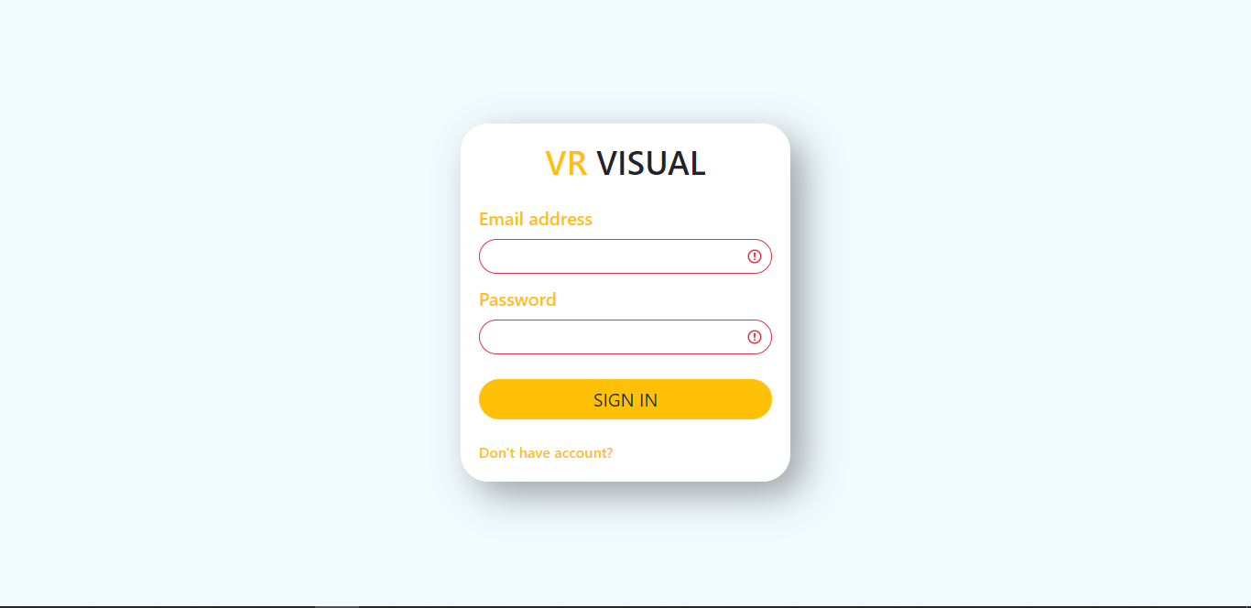

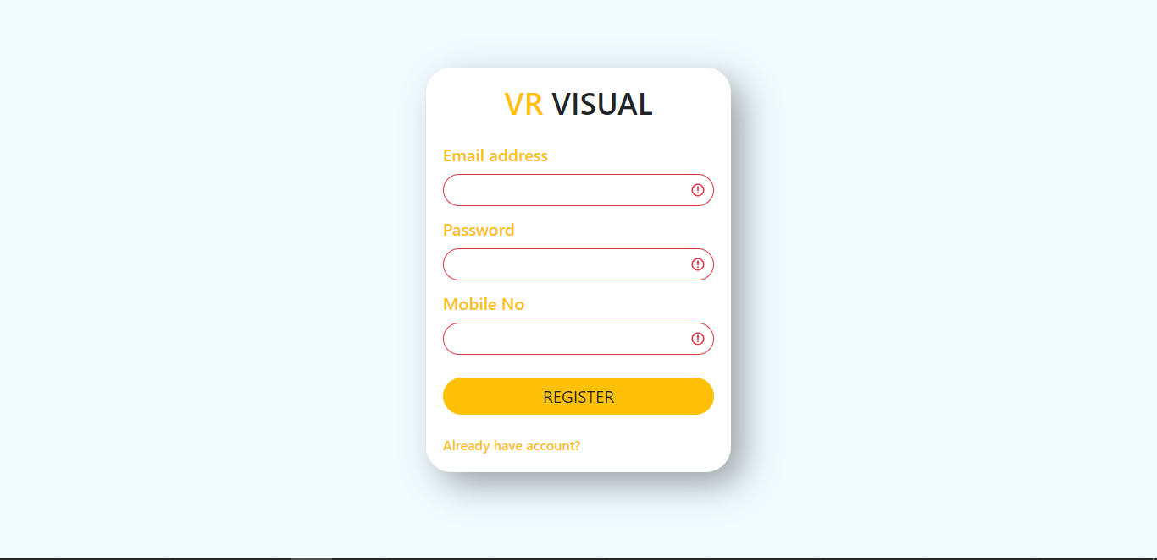

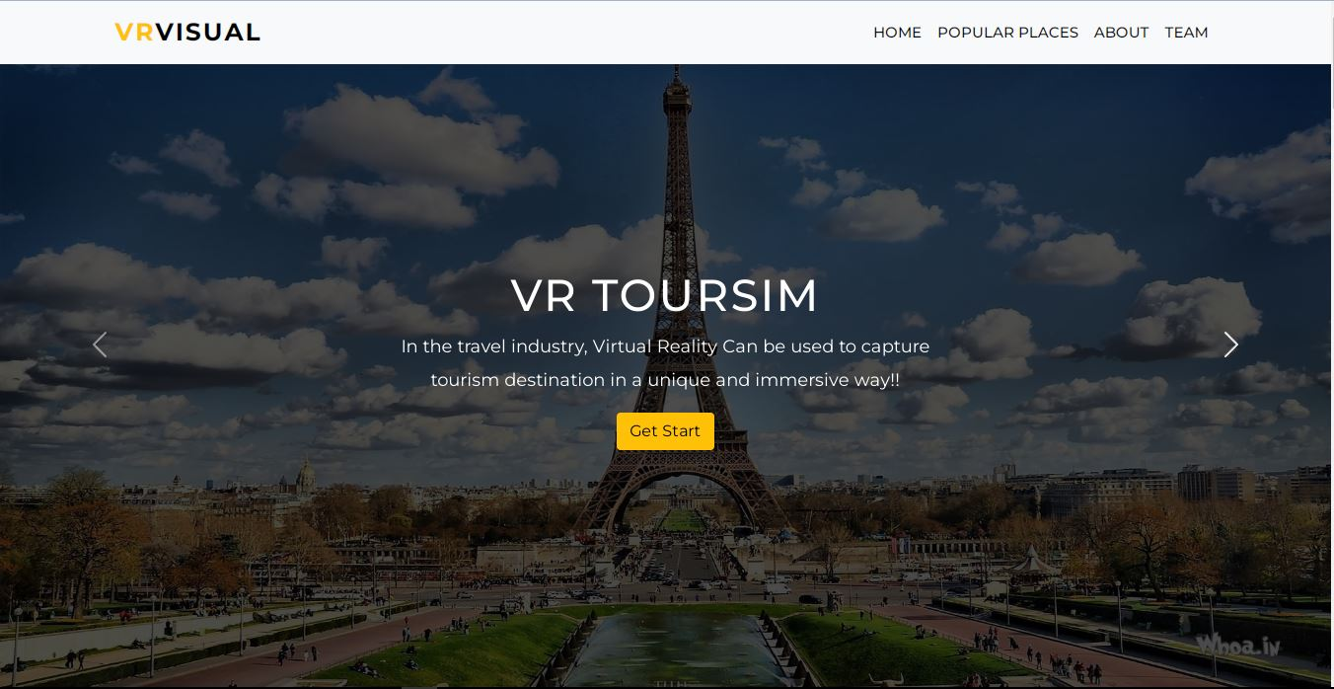

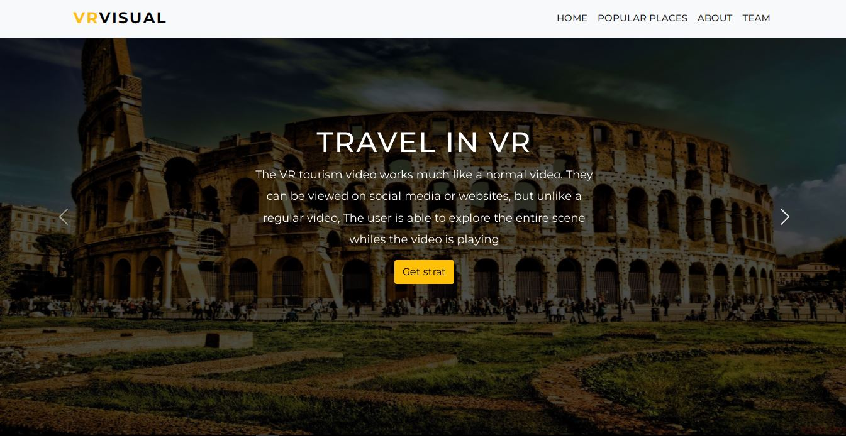

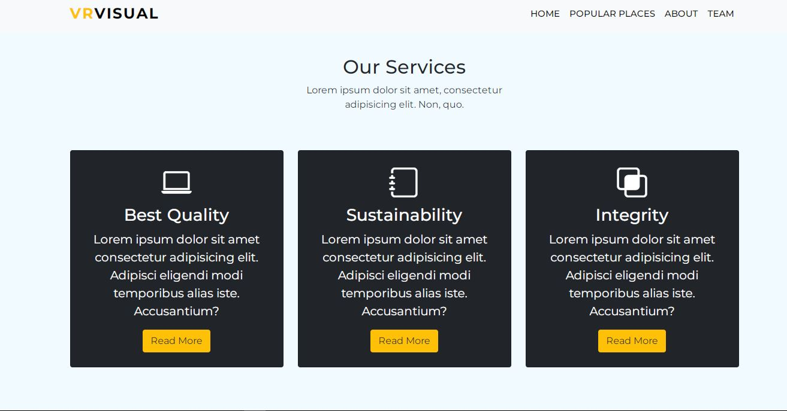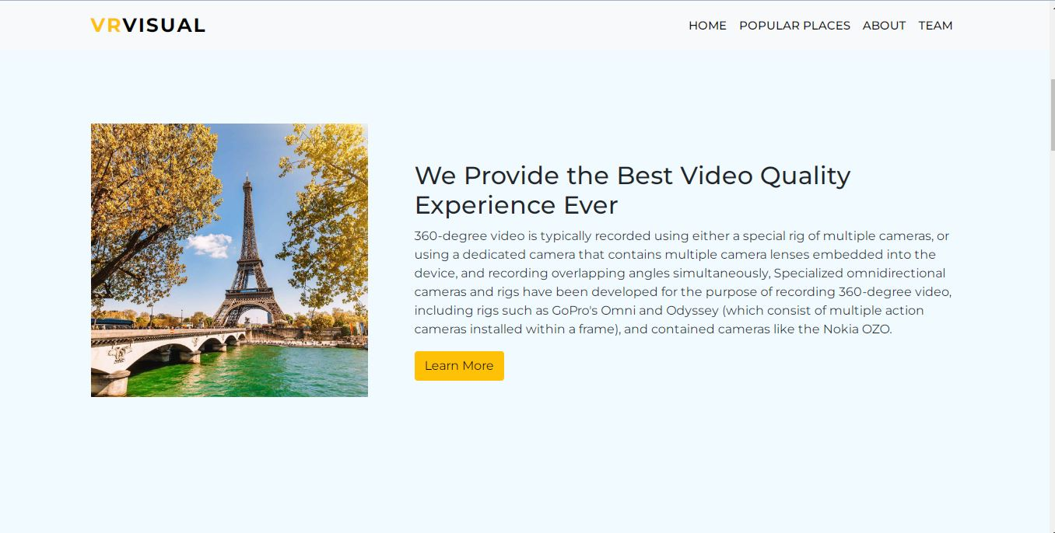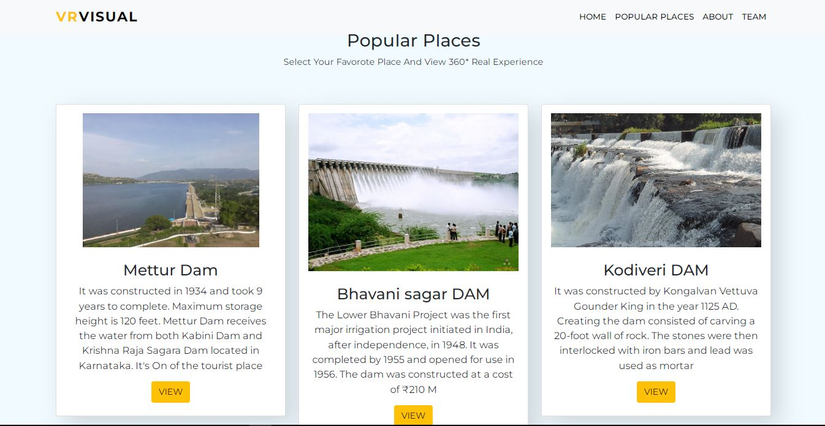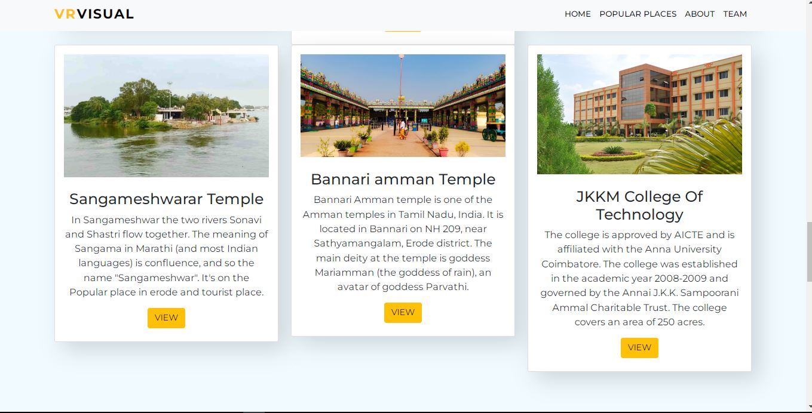 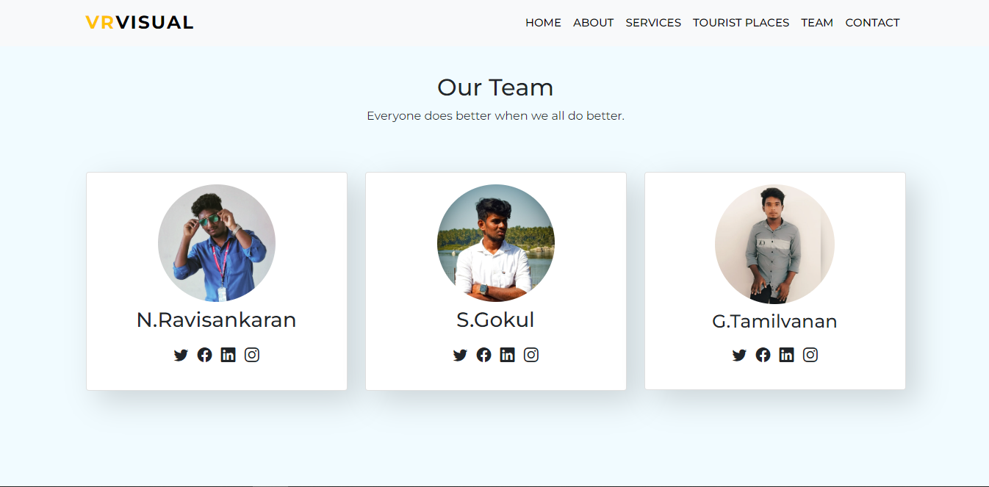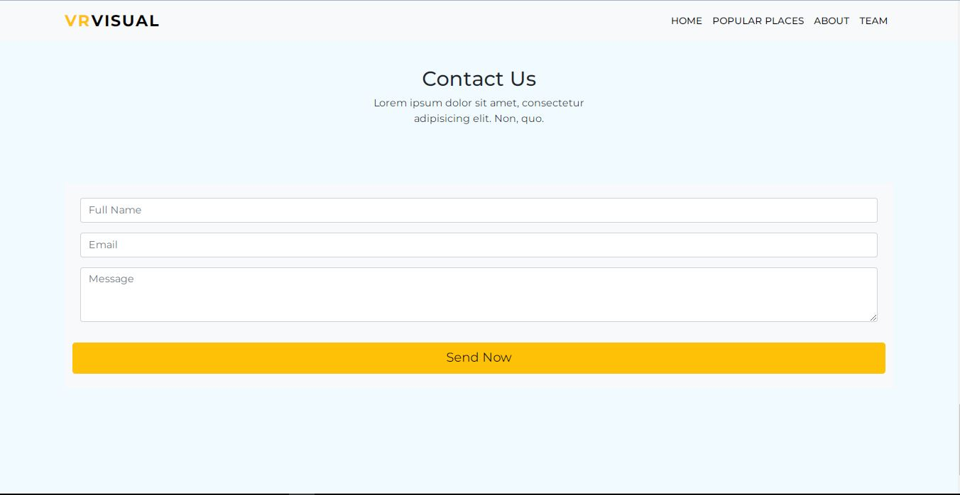

# REFERENCES

* + 1. author-Utilizing VR Technologies in immersive tourism Experiences.
    2. IEEE International conference on cognitive in info communications (con info com 2021) October 16-18,2021- Wroclaw, Poland
    3. AirPano (www.airpano.com): Provides immersive 360-degree aerial panoramas of various destinations, allowing users to virtually explore iconic locations.
    4. Expedia Virtual Tours (www.expedia.com/virtual-tours): Offers virtual tours of hotels, cities, and landmarks in partnership with local tour operators
    5. National Park Service (www.nps.gov): Offers virtual tours and multimedia experiences of national parks in the United States.
    6. VirtualTourist (www.virtualtourist.com): Features user-generated virtual tours, travel guides, and photos from destinations around the world.
    7. YouVisit (www.youvisit.com): Provides virtual reality experiences and virtual tours of popular destinations, universities, and attractions.